What to do when your Tenda U2 cannot install the driver automatically?

Model: Tenda U2 Problem classification: driver installation

Phenomenon 1: The computer system does not set the automatic playback function(Control Panel - AutoPlay – Use AutoPlay for all media and devices), the installation tips will not pop up after the insert of NIC, and you need to install manually.

Open the icon named “computer” or “my computer” or “this computer” on the computer desktop, find the “CD Drive Wireless”, right click it and then select “Open”;

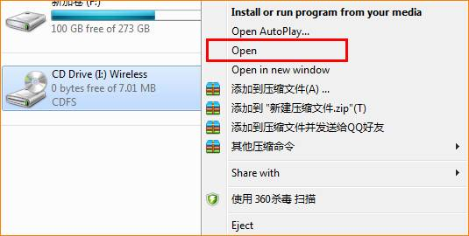

In the list, double-click the “Setup” application to start installing the driver;

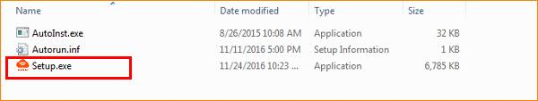

When the progress bar go to the end and disappear, and there will be a pop-up dialog box which reminds you that the installation has completed in the bottom right of the computer. Then you can connect to the Internet.

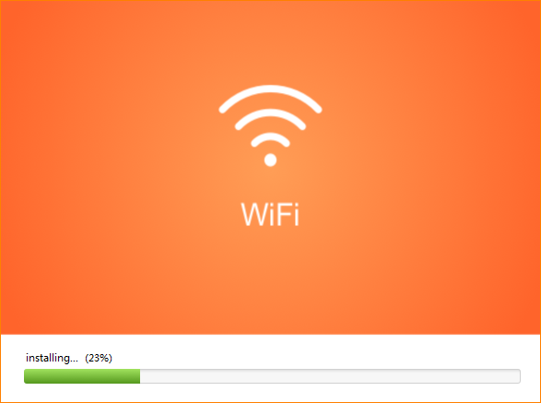

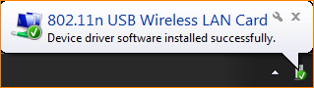

Phenomenon 2: The computer can not recognize CD driver. Please refer to the following steps (using Windows 7 as an example):

Click the “Start” icon on the desktop and select Control Panel;

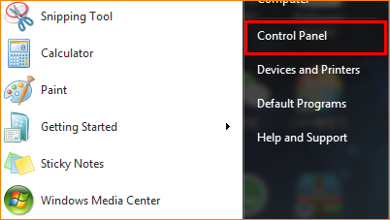

Click “Uninstall a program”;

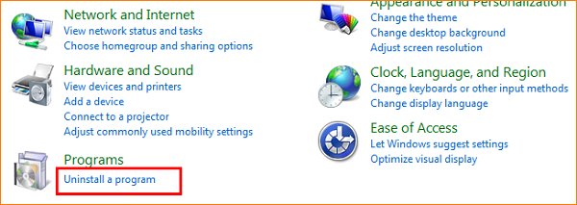

Find and uninstall other installed driver-free network card driver, and then reinsert U2, then you can start the installation.

